Lesson 5 Demo 9: Draining the Swarm Node

This section will guide you to:

* Drain the swarm node in Docker

**Step 1:** List all the active nodes

*sudo docker node ls*

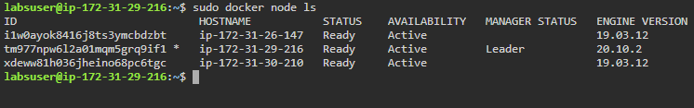

**Step 2:** Start a replicated service using the *redis* image

*sudo docker service create --replicas 3 *

*--name redis --update-delay 10s redis:3.0.6*

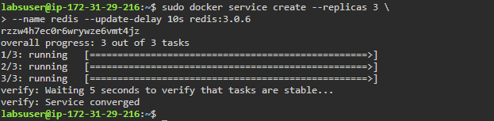

**Step 3:** Check the tasks assigned to different nodes by the swarm manager

*sudo docker service ps redis*

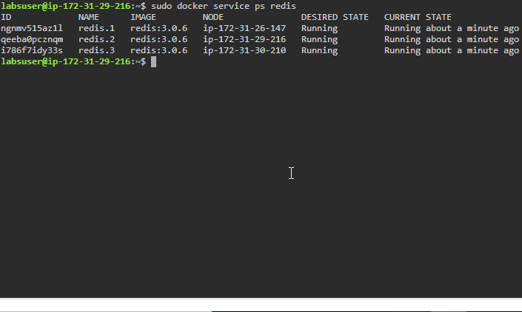

**Step 4:** Drain a node that has a task assigned to it

*sudo docker node update --availability *

*drain hostname_Worker1*

***Note:*** *Replace hostname_Worker1 with the IP address of your worker1 node. In this case it is ip-172-31-26-147*

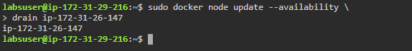

**Step 5:** Inspect the drained node and check the **Availability** of the node

*sudo docker node inspect --pretty hostname_Worker1*

***Note:*** *Replace hostname_Worker1 with the IP address of your worker1 node. In this case it is ip-172-31-26-147*

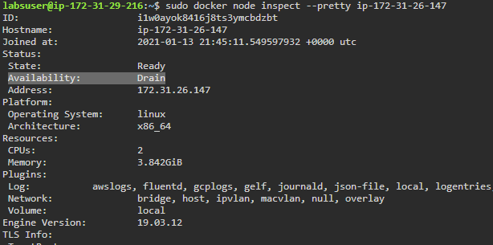

**Step 6:** Check the updated task assignments for the **redis** service by the swarm manager

*sudo docker service ps redis*

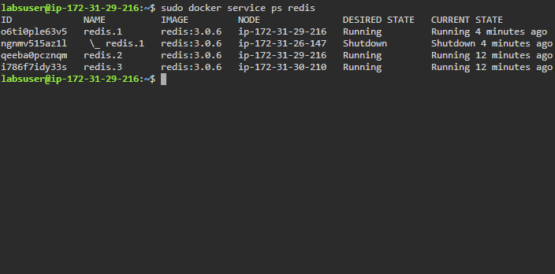

**Step 7:** Return the drained **worker1** node to an active state

*sudo docker node update --availability *

*active hostname_Worker1*

***Note:*** *Replace hostname_Worker1 with the IP address of your worker1 node. In this case it is ip-172-31-26-147*

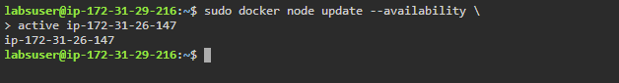

**Step 8:** Inspect the worker1 node again to see the updated **Availability** status

*sudo docker node inspect --pretty hostname_Worker1*

***Note:*** *Replace hostname_Worker1 with the IP address of your worker1 node. In this case it is ip-172-31-26-147*

